Board of Directors
Jorge Magana, President
Glen McLeod, Vice President Jim Keeling, Finance Officer
Matthew Starbuck, Director
Jeff Dotzler, Director
1550 East Burton Mesa Blvd, Lompoc
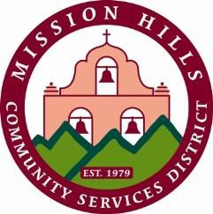
California, 93436-2100
805.733.4366
www.mhcsd.org Mike Garner, General Manager

Mission Hills Community Services District
SPECIAL MEETING
Water & Wastewater Committee
Wednesday March 11,2026
4:30 PM
1550 East Burton Mesa Blvd, Lompoc, CA - District Conference Room

Agenda

- Call to Order and Pledge of Allegiance
- Roll Call
- Public Comment
Members of the public may address the Committee regarding any items on this agenda. Public comments and suggestions are limited to three minutes.
- Discussion
  - Discuss the Capital Improvements Project Protocol

ADJOURN
In compliance with the Americans with Disabilities Act
If you need special assistance to participate in this meeting or if you need the agenda or other documents in the agenda packet provided in an alternative format, contact the Board Secretary at 805.733.4366 at least 48 hours before the meeting to ensure that reasonable arrangements can be made. (Agenda prepared under government Code section 54954.2)

